Basic User’s Guide
- First select the primary langauge you wish to use from the 'Dictionary language' control. Next, select the languages you would like to see entries for by ticking the appropriate 'Languages' box - EN, DE, PL etc. (You can choose two languages but not all combinations are available at the moment).
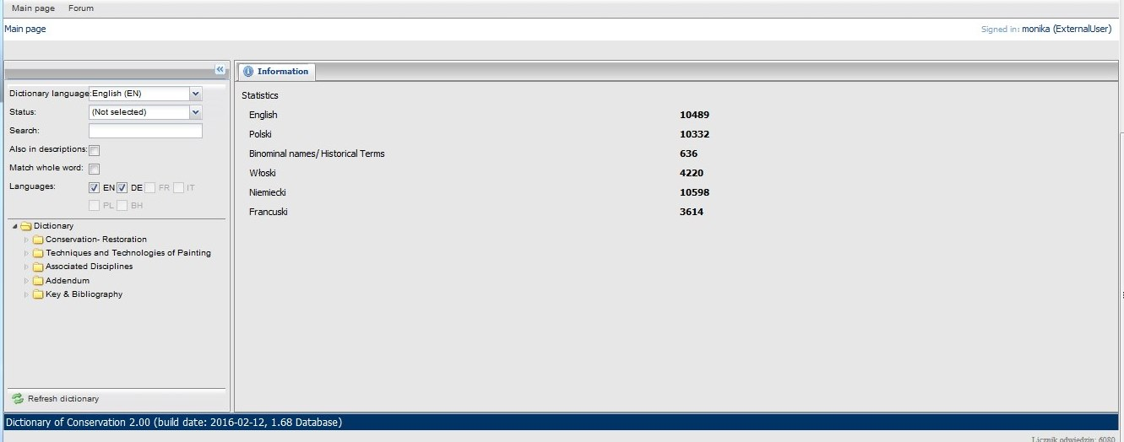
- In the dictionary tree, you can expand chapters by clicking the arrow in front of each chapter title. Note that in most cases, there will be many sub-chapters available.
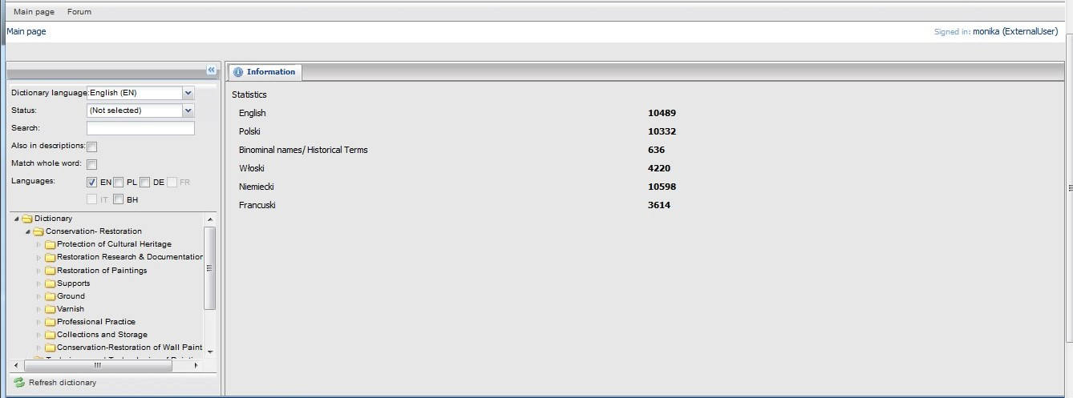
- Click the chapter’s title to see its contents. Associated entry headings are displayed beneath each chapter title and their descriptions are displayed in the main panel. In the bottom right corner, the total number of entries within the selected chapter is displayed (63 in this case).
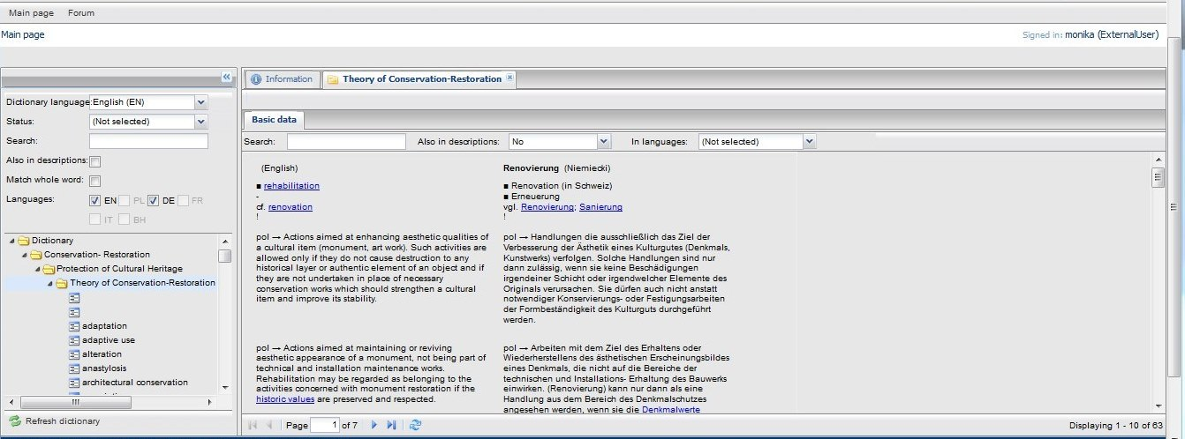
- Click an Entry in the dictionary tree to display its associated description in your selected languages.
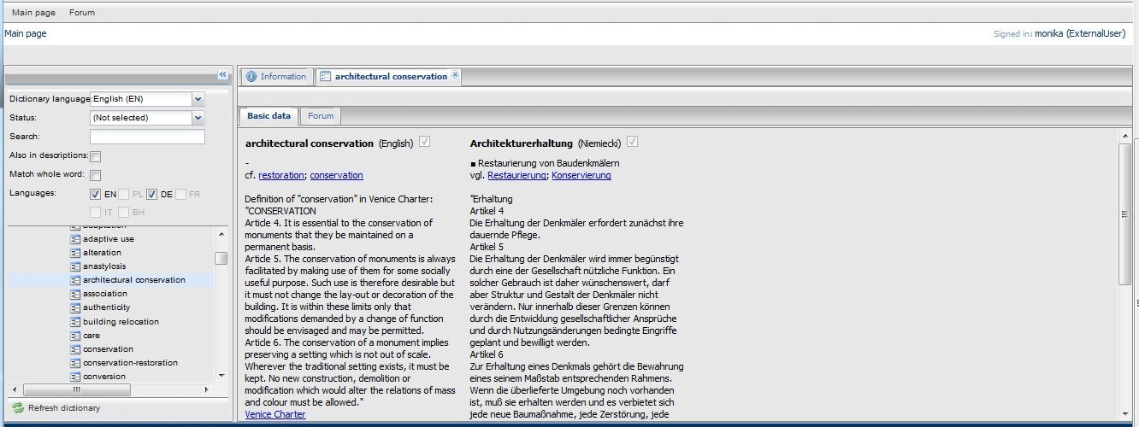
- To use the search facility, add a term in the 'Search' box and hit the enter key. All main entries containing the term will be displayed in the dictionary tree under the chapter the term is found within. In the example below you can see the results for the term 'panel'.
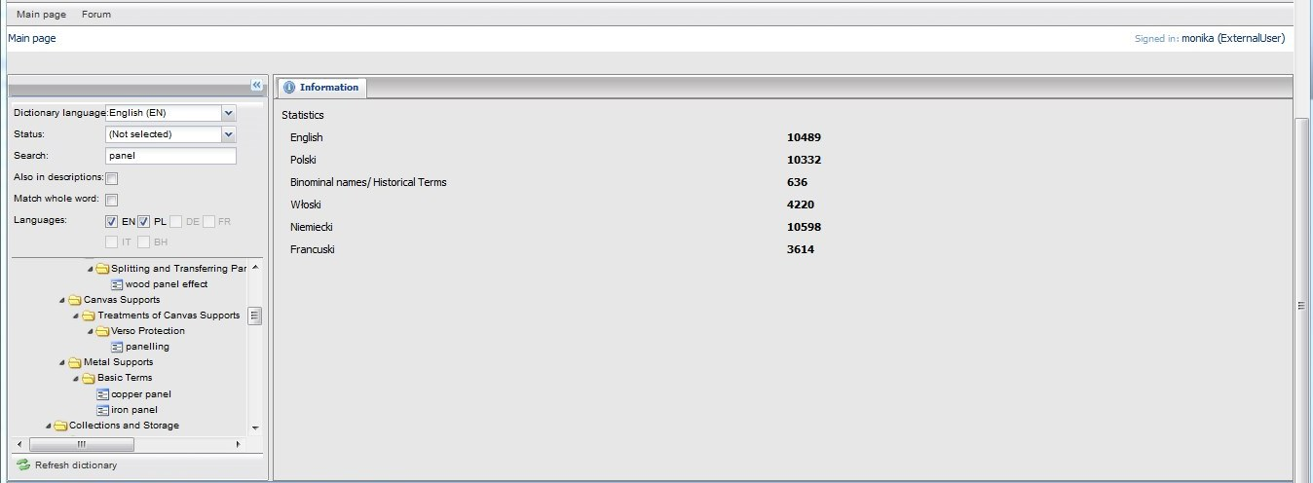

6. Select the term whose translation you require and its translation will be displayed in the main panel.
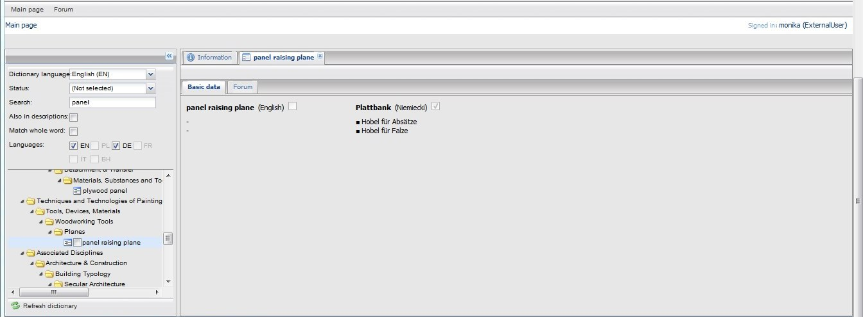
7. You can restrict search range by ticking the 'Match whole word' option. In the 'panel' example, this excludes 'panel support' and 'panelling' from the results.
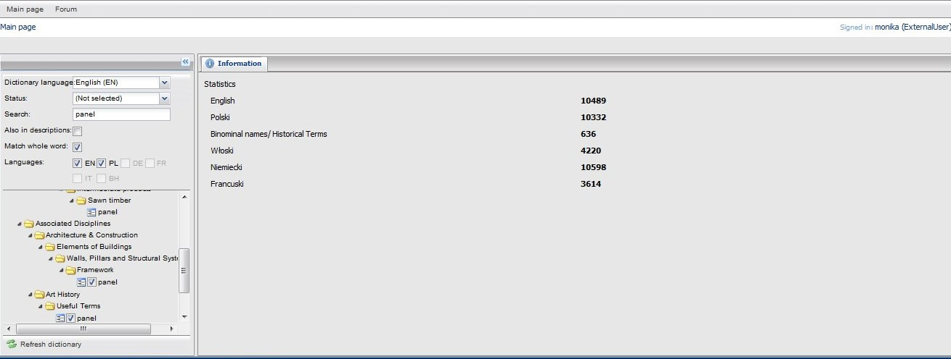
8. The 'Also in description' tick box expands the search to include the text of articles, rather than just the titles.
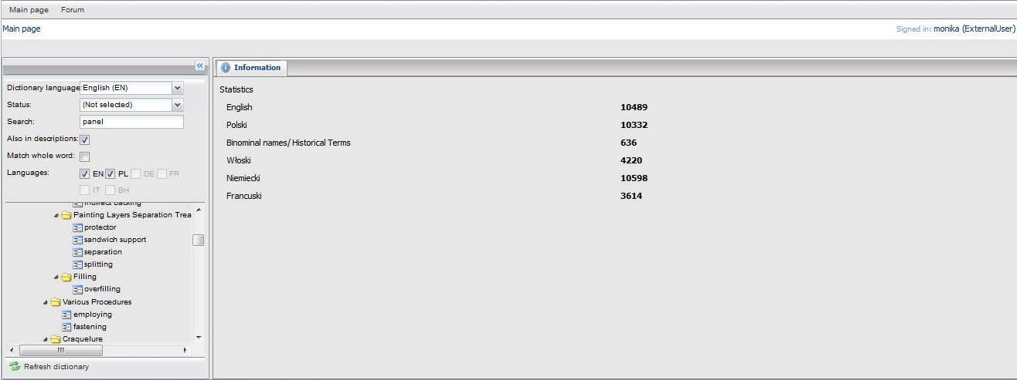

I. General Information
The Dictionary contains over 30,000 main entries and a number of additional entries. It is based on a hierarchical structure divided into thematic sections, with entries in alphabetical order. Some of the entries contain quotations, definitions and collocations.
The dictionary has been developed in five languages in parallel. The German, English and Polish versions contain ca. 10,000 entries each, while the remaining French and Italian versions contain ca. 4,000 entries per language. What is more, the dictionary contains historical terminology and binominal names.
Currently, a user can select only certain bilingual versions, for instance English-Polish or German-English pairs. As the study on the semantic and pragmatic equivalence (terminological comparative and conceptual analysis) is still pending, access to certain bilingual versions (e.g. German-Italian pair) is impossible at the moment.
The software, custom-made for the project, guarantees high transparency of the dictionary content in two fields – the main entry and the relevant article.

II. Dictionary functionalities

1. Account registration and login
To access the Dictionary, a user must register an account. Please read the terms of use before registration. Once logged in, select the language of descriptions and the language pair.

2. Search engine
The most important tool offered by the Dictionary is the search engine. A user may decide to search the main entries only or include the description fields in the search. Since in certain cases the requested entry may form a part of another word or term as an element of a compound, it is advisable to use the “Match whole word” option. For instance, the word build is a base word and, when prefixed, forms derivates: building, rebuiliding. The standard search will show all the foregoing words among results. When the “Match whole word” option is selected, only build will appear as the search result.
3. “Print Dictionary" function
An option to print certain sections is available for individual purposes only.
III. Main entries
Entries are terms composed of one or more words. Entries consisting of one word include only nous in the first case in singular or plural.
1. Entries consisting of one word have the form of simple words, e.g.: monument, restoration, retouch, conservation, retouching, painting, gold, painting, gilding, pressing
2. Entries may also have the form of compounds, e.g.: airport, keyboard, blacksmith, railroad, watchmaker.
Furthermore, the Dictionary entries include terms consisting of more than one word, e.g.: type of lighting, preparation of substrate, conservation-restoration, system of overlays, genuine gold gilding, etc.
Certain terms constituting entries differ in terms of morphology depending on language. For instance, a compound in one language may have a different morphological structure in another language. For example, the equivalent of the German compound Kunstdenkmal in Polish is a term composed of two words: zabytek sztuki.
Abbreviations, common names and document titles are also listed as entries, e.g.:
- PVCA (Polyvinylacetat), - I COMOS (EN: International Council on Monuments and Sites), - The Charter of Kraków, The Australian ICOMOS charter for the conservation of places of cultural significance
Unlike traditional general dictionaries, Interdisciplinary Multilingual Dictionary contains no information on grammar.
IV. Sample records in the entry field and in the entry article field
1. Main entry
Main entries are located in the entry field and are displayed in bold.
Example:
anastyloza | anastylosis
If an entry in the source language has no equivalent in the target language, the main entry field in the target language is empty, while the term is explained by description or by providing the semantically closest term.
Example:
working in white
A term used in reference to all works with whiting gesso, from the preparation of substrate to the smoothing and recutting of gesso. | Der in der polnischen Version des Wörterbuches angegebene Begriff "biała robota" (weiße Arbeit) bezeichnet alle Arbeiten, die sich auf das Grundieren und die Grundvorbereitung beziehen.
2. Synonyms, collocations, examples of use in sentences.
The synonyms of the main entry and the related terms included in the descriptive part of the entry are marked with ■ . These terms refer to the main entry in the source language only, and not to other language versions.
The mark ● is used for collocations and examples of use of the term in sentences.
Examples:
evidence | Beweis
■ testimony  -  - documentary evidence  - evidence in art history  - historic evidence  - testimony to our civilization testimony to our culture | ■ Nachweis  ■ Zeugnis  - schriftliche Beweise  - kunsthistorische Zeugnisse  - historische Zeugnisse/Nachweise  - Zeugnis unserer Zivilisation  - Zeugnis unserer Kultur
malowanie | painting
- malowanie na niezagruntowanym podłożu  - malowanie na podłożu chłonnym  - malowanie na zaprawie chudej/tłustej | - painting without a ground layer  - painting on the absorbent substrate  - painting on the fat/lean ground

3. Verbs
Verbs included in the descriptive part of the entry are given in infinitive and marked with ▼.
Example:
repainting | Übermalung
▼ repaint  - old paintings were frequently repainted for ritual purposes | ▼ übermalen  - aus spirituellen Gründen wurden alte Malereien regelmäßig übermalt

4. Quotations
Many entries contain direct or indirect quotations. Direct quotations are placed in quotation marks, with omissions marked with suspension points in round brackets (...)

Example:
primary yellowing
"By primary yellowing is meant a reaction causing a darkening which occurs in pictures that are newly painted or stored in the dark (...). It is dependent on the type and composition of the drying oil and its proportion in the color layer, the thickness of the layer and the relative humidity of the air."
Nicolaus, 1999, p. 158

The footnote in blue is a hyperlink linking to the relevant publication in the bibliography. Once clicked, the link opens a new window with full information on the specific source document.
Example:
Restoration of Paintings
K. Nicolaus, Restoration of Paintings, editor Christine Westphal, Koenemann 1999
Translated from German by J. Hayward, I. Macmillan, M. Pearce, J. Phillips, M. Scuffil, J.A. Underwood, and A. Vivis, in association with First Edition translations Ltd, Cambridge, UK.
Review of Nicolaus book is written by J. Hill Stoner, please note important remarks on English translation, cf.:
http://cool.conservation-us.org/waac/wn/wn22/wn22-1/wn22-107.html

5. Links
Terms in blue and terms preceded by references such as: see; see also, cf. are in the form of hyperlinks as well. They offer a possibility of verifying a related, similar or synonymous term. The same hyperlink tool has been used to enable viewing illustrations.

Example:
aureola | technika aureoli
■ pictura translucida painting  -  cf. pictura translucida  cf. In what manner this tin when gilded can be used for the glories of saints on walls  cf. colouring of silver | ■ pictura translucida  ■ aureola  zob. technika aureoli  zob. też Jak z takiej cyny, pokrytej szczerym złotem, możesz robić korony świętych na murze  por. kolorowanie srebrzeń

6. Language codes
The three-letter language codes adopted in the dictionary follow the ISO 639-2 standard. The code of language accompanied by an arrow indicates the source language of the translation (qualifies the direction of the translation)
eng → ; fra → ; ger → ; ita → ; pol →
Note:
Certain entries were excerpted from sources developed in many languages in parallel, e.g. conventions, agreements or other international deeds. In this case the source language of the translation is not specified. The same applies to quotations excerpted from the official translations of sources used in the Dictionary and to the collocations and the examples of use of a term in sentences contained in the descriptive part of an entry.
7. Original notes and texts
In certain cases it was necessary for the authors to include explanations and comments in the descriptive field of the entry. Such comments and notes are marked with the author’s initials.

Example:
 | pomnik historii
■ (protected as a) historic monument  ■ (protected as a) historic site/ area  Listing the heritage object as a "pomnik historii" is one of the forms of legal protection, and it refers mainly to areas and sites. The term was introduced in 1990. This type of protection is declared by the President of Poland and the first sites protected as "historic monuments" were declared by President Lech Wałęsa in 1994; the Kraków city centre was one of the first on the list. MB | ■ (chroniony jako) pomnik historii  -  Uznanie obiektu dziedzictwa za pomnik historii jest jedną z form ochrony prawnej; odnosi się on głównie do obszarów i miejsc. Termin wprowadzono w 1990 r. Ten typ ochrony wprowadzany jest przez prezydenta RP; pierwsze miejsca chronione jako pomniki historii zostały wskazane przez prezydenta Lecha Wałęsę w 1994 r., centrum Krakowa było jednym z pierwszych na liście. MB

